**BUSINESS ANALYSIS PROJECT**

Group 2:

Linxsly ALEXIS

alexislinxsly@gmail.com

David LOUIS

loulludave@gmail.com

Yvesna MARCELIN

yvesnamarcelin48@gmail.com

Jeffking Sterile

wizking5000@gmail.com

**Boutique Product Analysis**

Introduction

Business analysis is the practice of enabling change in an enterprise by defining needs and recommending solutions that deliver value to stakeholders. It’s also a disciplined approach for introducing and managing change to organizations, whether they are for-profit businesses, governments, or non-profits.

It allows organizations to structure how they make decisions to change their strategy in order to reach their desired objectives.

**Define the problem**

1. Context

The analysis that we are doing here concerns a store which sells various products.

Michel, the owner of the store, has been confronting a problem for three months. This problem has been arising every time he has to order tomato paste. He often realizes that he has to throw out many expired cans of tomato paste each month.

1. Problematic

The problem of Michel's company is an overload of his stocks of tomato paste can. In fact, he couldn't sell them all and the loss rose every month.

Background of the problem

Who identified there was a problem? Have there been any other attempts to solve this problem?

Michel, the boutique store owner, identified the problem. He talked about it with his son but no attempt has been made to solve this problem.

1. The stakeholders involved in the problem

* The owner and his son
* The clients
* The providers and all those who have participated in the supply chain (Bus driver…)

The main stakeholders are Michel the owner, and his son who also seems to be responsible.

After that, the problem affects the clients because they tend to buy less.

Then, it can affect the providers and all those who have participated in the supply chain such as the driver of the bus…

It can also affect other people such as those who risk losing their jobs if the boutique goes bankrupt.

The stakeholders can also be those who invest in the company, i.e. the shareholders, they also risk losing their investment.

Measures of Performance

How do the client, organization and other stakeholders measure the Business Problem?

The boutique store owner, Michel, has a record on how many boxes of tomato paste he buys on each brand; how much he buys them. He also has information on daily sales of the last 3 months.

1. Importance of the problem

This problem is important for the company because it can make it go bankrupt. Any company that sells goods and has a problem of stock management is confronted with it. It is effectively the case of the company of Michel.

**Methodology**

Firstly, we will collect data for the analysis. We will use the data related to the purchases and sales of the company.

Secondly, we will use Excel to manipulate the data. We will start by treating the data and then we will look for the quantity sold each week and also for the quantity of items purchased. We will evaluate losses and profits and we will proceed in this way for each brand. And then, we will use mathematics and statistics tools such as average, sum, trends to make calculations based on the information on the daily sales. To determine if the owner was making profit or loss. Then assuming that a can of tomato paste can only last a month we determine the quantity of boxes he loses per month. And then based on the average he sells every two weeks we set an average of the quantity of boxes he should buy in case the owner chose to still sell tomato paste.

**Results**

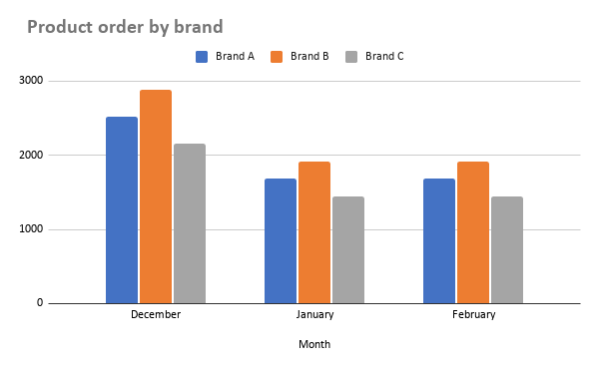

This graph represents the number of products ordered by brand per month. We can therefore notice that the order per month is higher in the first month. Especially for brand B, the company orders almost 3000 products in the first month. But for the second month they ordered a quantity inferior to 2000.

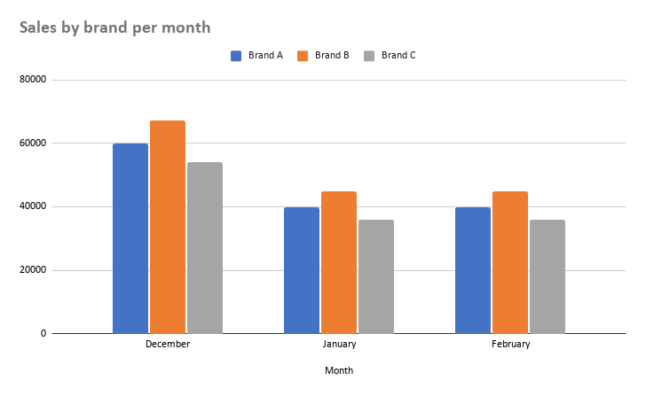

This picture represents the sales of tomato paste can by brand per month. It shows that every single day the Boutique sells the same number of cans for each brand.

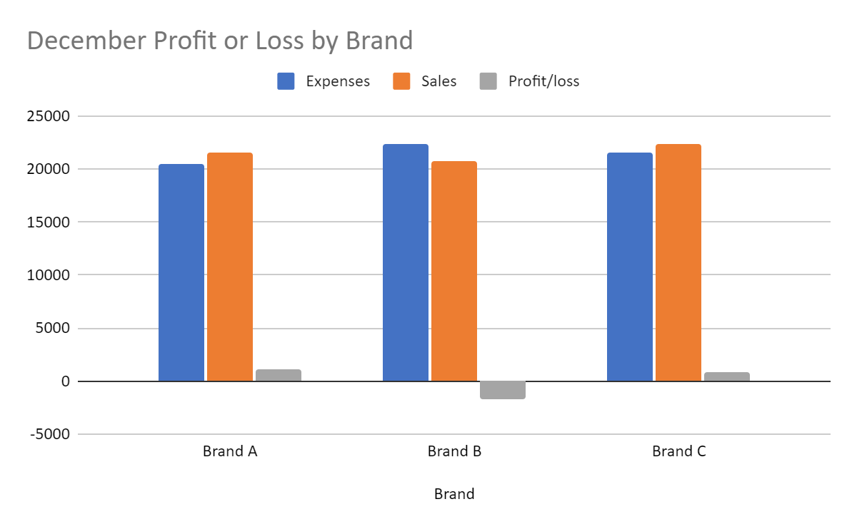

This graph shows the comparison between the amount of sales and the cost of products sold, the objective is to show if the store made a profit or a loss during the month of December. For Brand A and Brand C it shows that the boutique has made a little profit while brand A made a loss. This graph also shows that the store does not make enough profit compared to its expenses, profits represent less than a quarter of the expenses incurred.

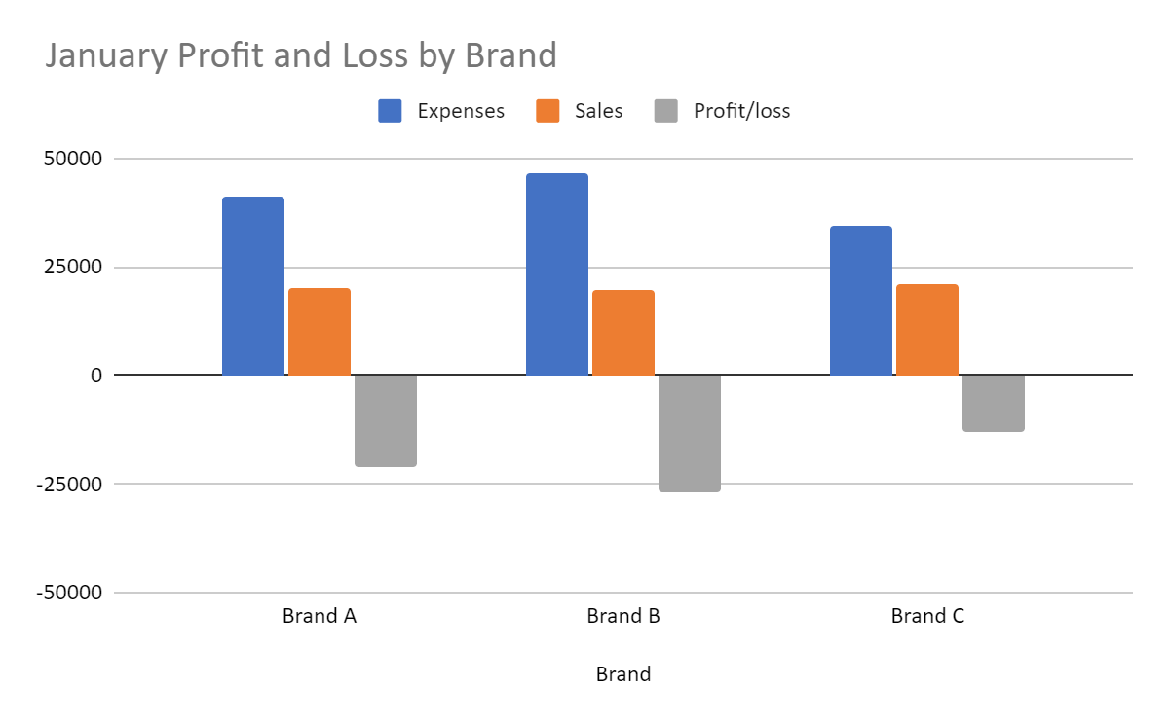

This graph shows the Profit and Loss in January. The store experienced considerable losses in all brands during the month of January. The losses of Brand B exceeded 25,000 gourdes.

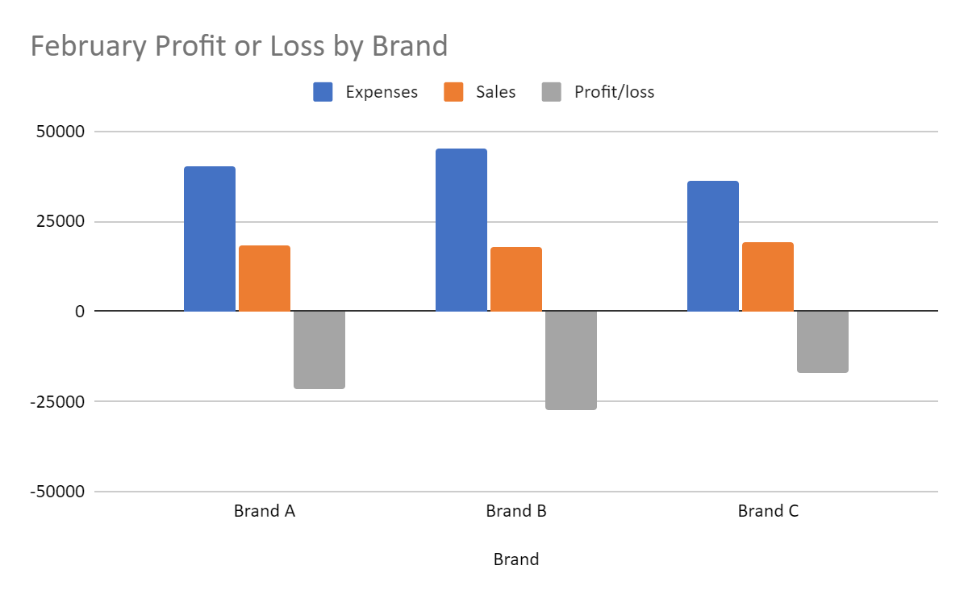

This graph represents profit and loss in February. For the month of February, the store has again experienced considerable losses. The losses of brand B have again exceeded 25,000 and brand B is very close to the same level of loss.

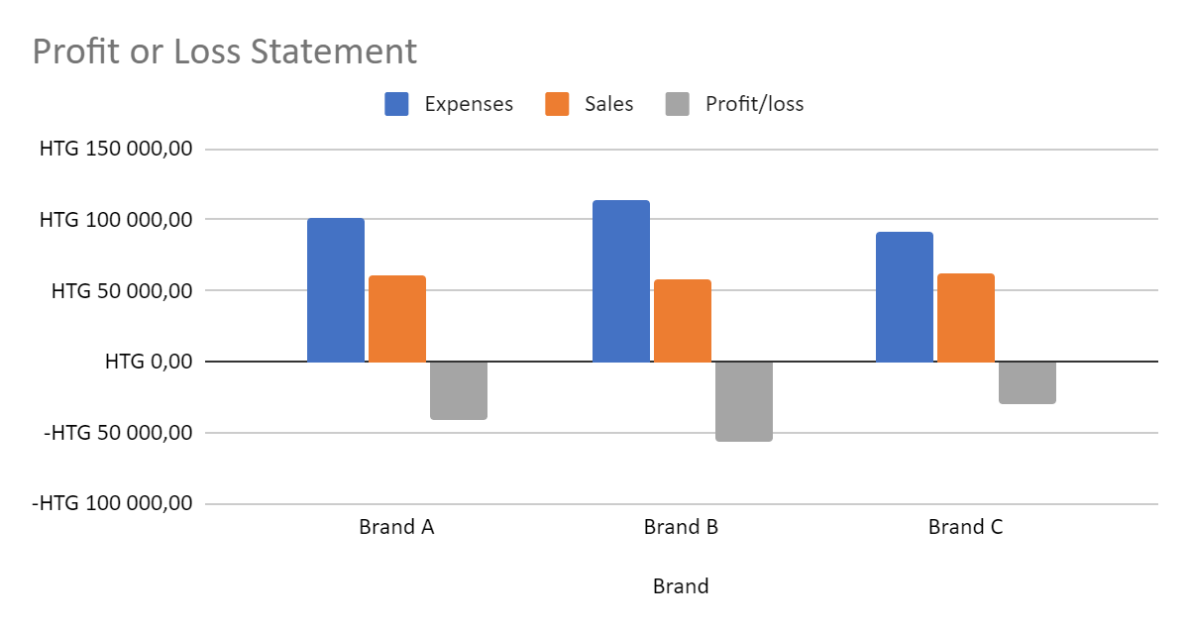

This graph is the summary of the past 3 months of services of the boutique. It shows the profits and losses experienced by the boutique.

**Discussion & Proposed Solution**

SWOT Methodology

SWOT (strengths, weaknesses, opportunities, and threats) analysis is a framework used to evaluate a company’s competitive position and to develop strategic planning. SWOT analysis assesses internal and external factors, as well as current and future potential.

**Strengths**

1. Multiple brands
2. Record of each transaction
3. Stock on time

**Weaknesses**

1. Problem of management
2. The brands don’t really affect the customers
3. Lack of information on the market

**Opportunity**

1. Organize a market research based on a survey
2. They can use the result of the business analysis to adjust their stock
3. Adjust their business to the market trends

**Threats**

1. The waste of so many products
2. A considerable loss
3. The lack of business analysis
4. Bankruptcy

**Main solution**

By analyzing the data to propose a solution, we can conclude that the boutique hasn't only a stock management problem. There are some problems in the fixation of the sales price of each product. The expected profit is no greater than 3.87%. It is very difficult for an organization to survive without management in general. For this reason, we can believe that with great management, the boutique can survive much longer. In that case, here are our recommendations.

**Solution 1**

The owner has to put in place some stock management processes such as:

* They have to change the order’s composition.

They can order a different quantity on each brand. According to the trends we’ve calculated.

Strength of the organization

Stock on time

They will always have boxes of tomato paste on time.

Record of each transaction

The fact that they record every transaction could help them better control their tomato paste stock.

Strength of the solution

It will reduce the waste of cans in the other brands. By reducing the number of boxes in the other brands we can serve the population without these big losses.

It will increase the profit by decreasing the loss.

Weaknesses of the organization

Lack of information on the market

We can consider the lack of information on the market as a weakness. If they don’t do market research, they won’t have pertinent data.

Weaknesses of the solution

If the owner sells only one brand, customers will have no longer choice. And we know that people like to have choices. According to the quality of life of a person, he will tend to consume luxury products. If we opt for this choice to people.

Challenge you might encounter?

Management problem

If the management problem persists it will be very difficult for them to implement the solution.

We don’t know exactly what the trends will be in the future. Because we don’t know exactly the reason why the population tends to buy a brand instead of another.

How to face them?

We have to organize surveys to know the market trends and market research to better understand the population we will have to serve and better segment the market according to the needs of each category.

* Recommend the owner to reduce the order of brand B and increase the order of brand C.

Strength

It will increase their profit and they will manage their stocks better.

Weaknesses

Clients who buy brand A and brand B might get upset. Especially because Brand A and C are inexpensive.

* **Solution 2**

We are proposing that they do a market research

Strength

Market research help you minimize risk

Market research can help you establish trends.

Market research helps identify competition

Market research helps identify potential problems

* **Solution 3**

Another solution we are proposing the client is to reduce the quantity of tomato paste boxes he buys per fortnight.

**Strengths**

* A better control on the management, the supply.
* Increasing global revenue of the boutique
* Reduction near to zero of the waste of products
* Satisfaction of client’s desire

**References**

1. [www.marketsandmarketsblog.com](http://www.marketsandmarketsblog.com)
2. [What is Business Analysis? | Global Standard for Business Analysis Certification | IIBA®](https://www.iiba.org/professional-development/career-centre/what-is-business-analysis/)
3. [Strength, Weakness, Opportunity, and Threat (SWOT) Analysis Definition (investopedia.com)](https://www.investopedia.com/terms/s/swot.asp)